Ekovya
Customizing guide WooCommerce

- With are necessary plug-in on WooCommerce and where can we found them?

On the dashboard of Sandboxe Wordpress, go to menu on the left and click on Plugins.
1

1
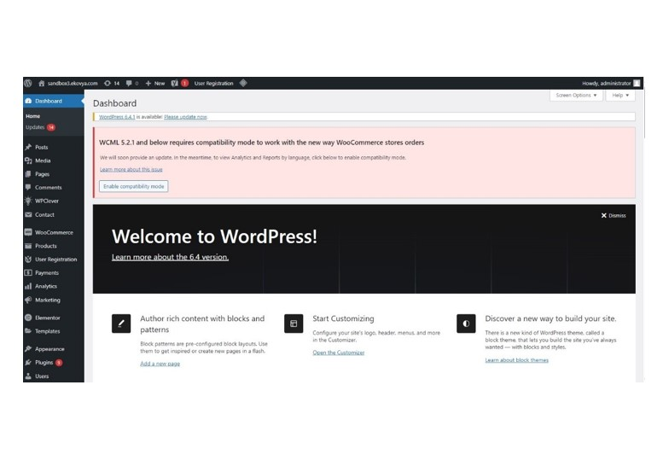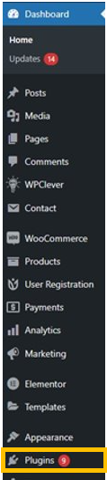

2
See the list

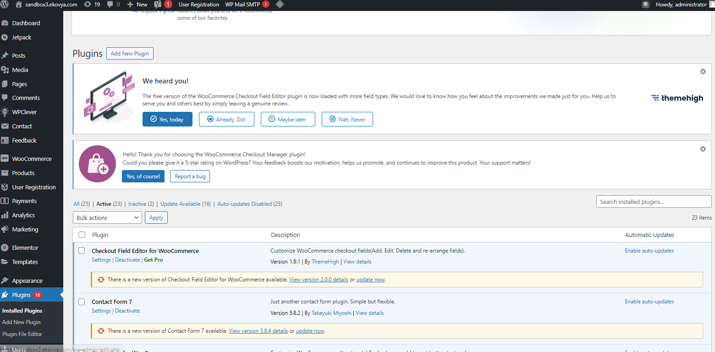

3
List

Plug-In | Définition
WooCommerce (e-commerce) | Allows to manage online shop
Woocommerce Checkout Manager (Lotfi ?) | Allows customizing checkout page
Wordfence Security (security) | It allows protect website WordPress
WP Everest User Registration | Allows the implementation of a customized form to allow visitors to create accounts on the website.  /!\ Free version only: some customized fields (such as “company” and “SIRET”) are not connected to the equivalent standard fields in WooCommerce. Thus, the object “Customer Account” contains duplicate fields. Customized fields are filles by visitors and appears in the WooCommerce interface. The standard fields are not automatically filled.  /!\ Power Automate WooCommerce connector recognize only standard fields. To allow data synchronization between Salesforce and WooCommerce, Sales Representatives must manually complete the standard fields with the data contained in the customized fields. Account and Contact are created/updated in Salesforce by updating the Customer Account in WooCommerce.
Elementor PRO (Web Design) | Create web page without code
WP Mail SMTP | Send email via WordPress
Newsletter, SMTP, Email marketing and Subscribe forms by Brevo (Dyhia) | Lack of information. Must confirm necessity
LiteSpeed Cache (Lotfi?)

Checkout Field Editore for Woocommerce (Etienne/Lotfi)

Contact Form 7 (Etienne?) | Allows insert contact form
Customizer for Woocommerce (Lotfi?)

Power Automate for Woocommerce | Allows connection between WooCommerce and SalesForce
Woocommerce Google Analytics Integration | Allows analysis performance website
Woocommerce Multilingual & Multicurrency | Allows some linguals and currency on website
Woocommerce shipping & tax
Wordpress Importer | Allows to download all media files (images) in one folder (fast) instead of each one apart (slow)
WPC Price by Quantity for Woocommerce | Add degressive price in relation to the quantity purchased
WPC Product Bundles for Woocommerce | Create product bundles. This means making offer with some products in same package

4
Add new plug-in

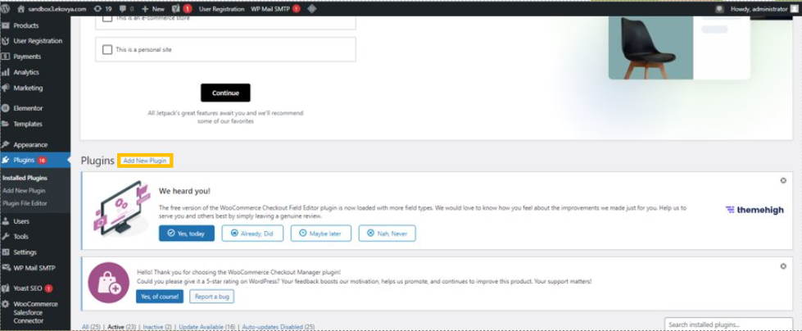

  - Link Mock up

Website mock up

Product sheet

10
1 Click on publish on the right

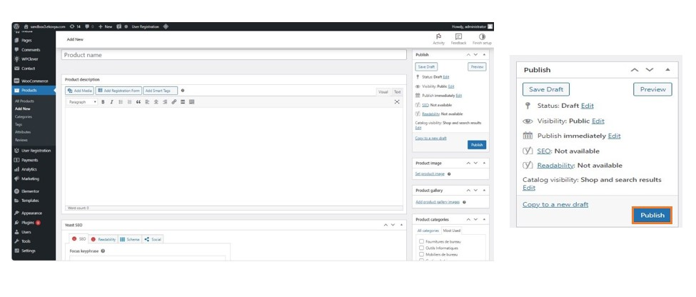

How create bundle ?

1
Go to Product Data and click on Smart bundle

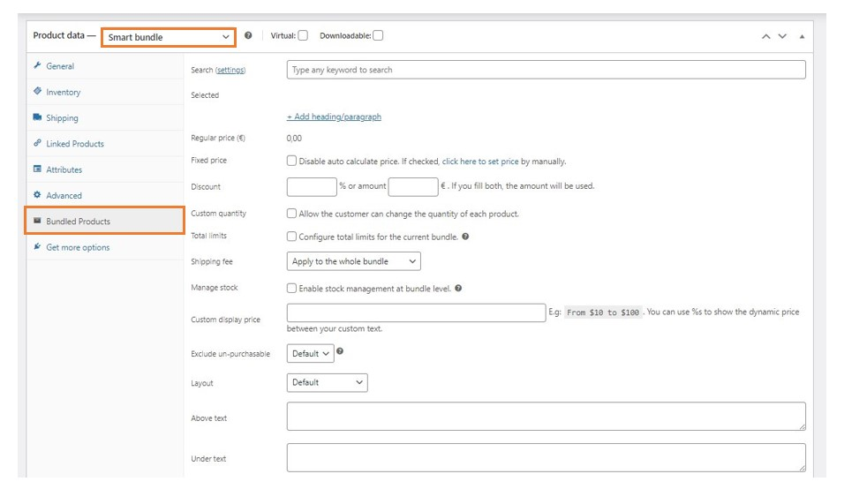

2
Add products

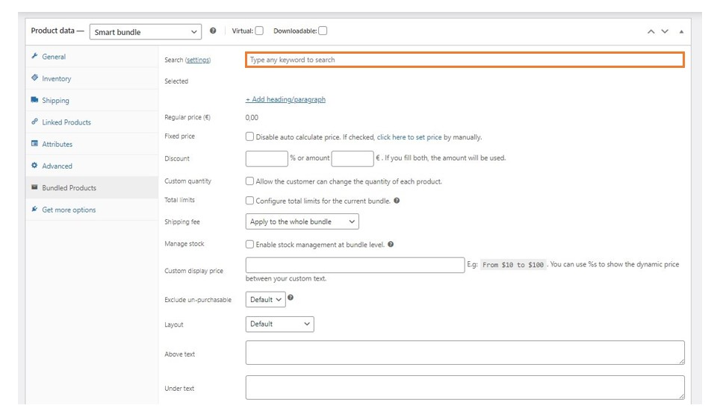

How create up sells or cross sells?

1
Go to product data and linked products.

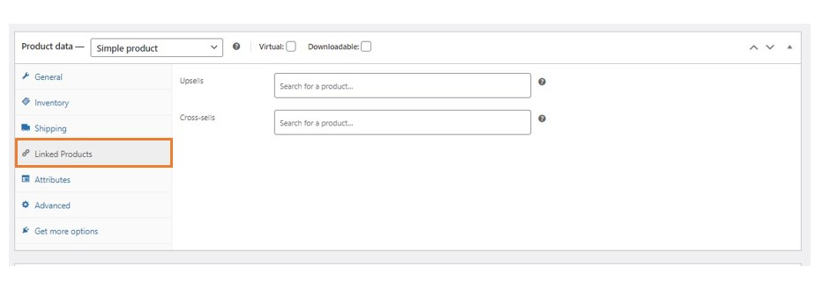

2
Add products for up sells or cross sells

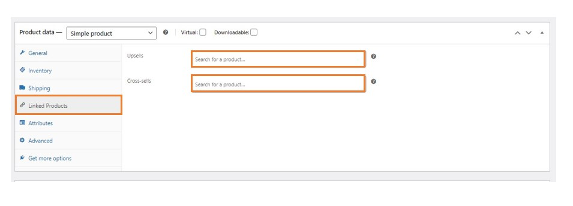

How create account / validation procedure?

Go to users and choose one user for approved.
1

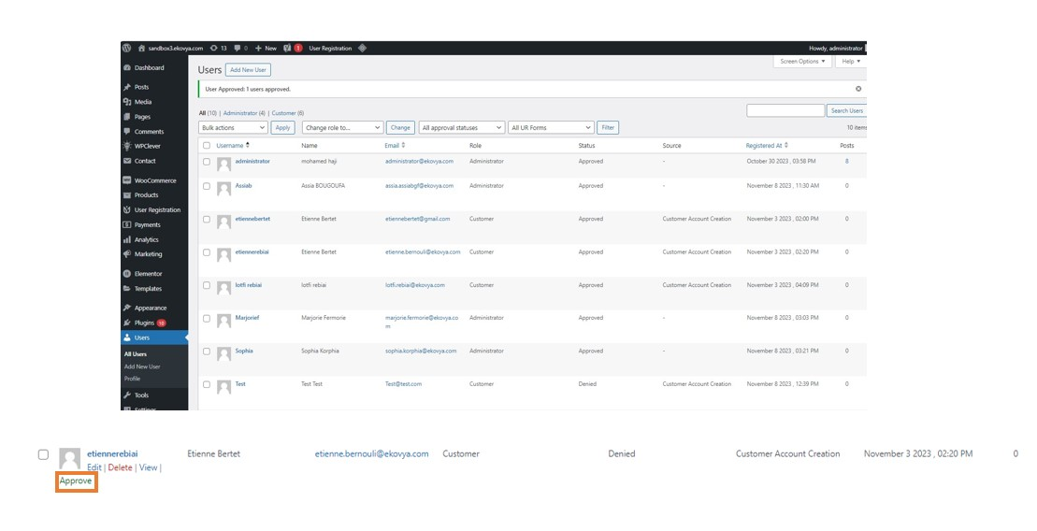

How search products and addition to basket

Ordering a product on Ekovya

Go on Oders and click on Add order
1

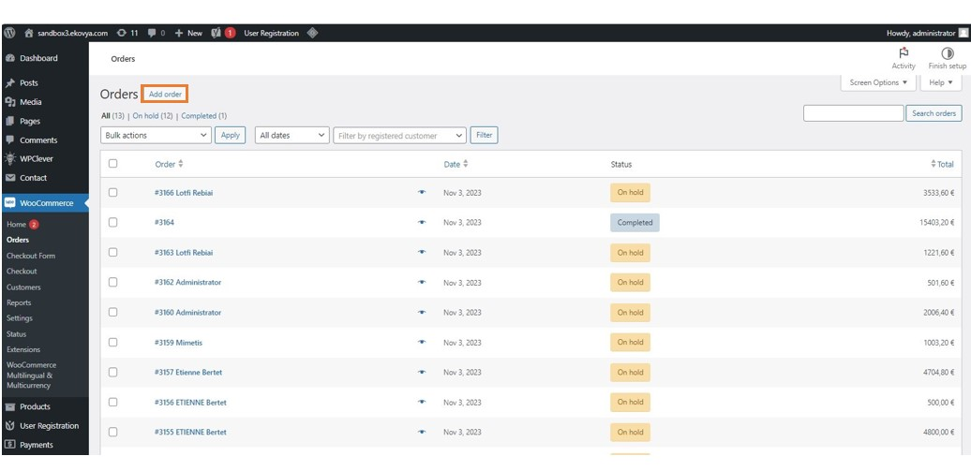

Edit the order and click on create
2

